RippleWealth – AI-Driven Investment Risk Intelligence Platform
Sharvani Kadarla^{#1}, Deepali Sawant^{*2}, Jai Sheel Bhasker Paladugu^{#3}, Ashish Reddy Majjigapu^{#4}
#Department of Computer Science, Pace University
New York, USA
¹sk10362n@pace.edu
²ds83110n@pace.edu
³jp03982n@pace.edu
⁴am37448n@pace.edu

Abstract— Modern investment platforms are largely reactive, alerting investors only after stock prices have already shifted. RippleWealth is an AI-driven investment risk intelligence platform designed to move beyond reactive price-based analysis by detecting early real-world signals—such as weather events, supply chain disruptions, and labor strikes—before they manifest in financial markets. Utilizing a multi-agent AI architecture and Large Language Model (LLM)–based causal reasoning, the platform maps disruption propagation across industries to provide proactive, explainable risk insights. This study details the system's architecture, including its integration of geospatial infrastructure data and natural language advisory agents.

Keywords— AI-driven finance, risk intelligence, causal reasoning, knowledge graphs, investment management.

- INTRODUCTION
The modern investment landscape is characterized by high volatility and an overwhelming influx of real-time information. However, traditional investment platforms remain largely reactive, typically alerting investors only after significant stock price movements have occurred. This technological lag exists because current tools focus almost exclusively on lagging financial indicators while ignoring early, non-financial risk triggers such as supply chain disruptions, extreme weather events, labor strikes, and logistics delays. Consequently, both retail and professional investors lack the proactive insights and clear causal explanations necessary to anticipate risk before it manifests in asset prices.

The current study focuses on the development of RippleWealth, an AI-driven investment risk intelligence platform designed to move beyond traditional price-based analysis. Unlike standard tools, this work utilizes a multi-agent AI architecture and Large Language Model (LLM) causal reasoning to detect "Butterfly Events"—small-scale real-world disruptions—and trace their propagation pathways across global industries and specific company holdings. By integrating interactive Knowledge Graphs and explainable risk metrics such as Value-at-Risk (VaR), this effort seeks to advance understanding of systemic risk propagation. The relevance of this work lies in its ability to empower investors with transparent, data-driven narratives, transforming risk management from a reactive necessity into a proactive strategic advantage.

- LITERATURE REVIEW
The evolution of investment risk management has transitioned from basic statistical models to complex, data-driven systems. Historically, the assessment of market risk relied almost exclusively on lagging financial indicators and historical price volatility. While these traditional tools are effective at reporting what has already occurred, they are inherently reactive and fail to account for early, real-world signals.

A. Reactive vs. Proactive Risk Intelligence

Modern investment platforms typically alert investors only after stock prices have already shifted. This creates a significant information gap, as the primary drivers of market shifts—such as supply chain disruptions, extreme weather, and labor strikes—often occur days or weeks before they are reflected in financial data. The study explores moving beyond this reactive analysis by detecting "Butterfly Events" as they happen to provide early insights into potential portfolio impacts.

B. Causal Reasoning and Knowledge Graphs

Existing financial tools often suffer from a "black-box" problem where users cannot see the underlying cause-and-effect of why portfolio risk is increasing. Research in quantitative finance has recently begun to explore graph-based models to map systemic risk pathways. This work advances the field by using Large Language Model (LLM) reasoning and multi-agent AI to simulate second- and third-order domino effects. Unlike manual scenario modeling, which is time-consuming and often lacks integrated causal analysis, this study utilizes Neo4j to visualize direct and indirect impact paths through an interactive Knowledge Graph.

C. Alternative Data and Infrastructure Risk

The integration of alternative data—such as logistics reports, weather feeds, and labor news—is critical for accurate risk forecasting. This research further distinguishes itself by incorporating regional infrastructure data, specifically broadband and geospatial connectivity metrics. By comparing global events with specific regional vulnerabilities stored in SQL databases, the study provides a more granular risk assessment than platforms that rely solely on macroeconomic indicators. This shift toward explainable, signal-based intelligence ensures that risk metrics like Value-at-Risk (VaR) are grounded in real-world causality rather than historical probability alone.

- PROJECT REQUIREMENTS
Mentioned below are the product requirements for making sure the work runs at optimal performance and fulfills its defined functional requirements.
- Software Requirements
- Backend Framework: FastAPI (Python) for building high-performance RESTful APIs, managing user authentication, and coordinating risk calculations.
- Frontend Framework: React (Vite) for the interactive dashboard and Knowledge Graph visualizations.
- Database Management: A hybrid approach using PostgreSQL (via SQLAlchemy) for relational data and Neo4j for causal impact graphs.
- AI & Analytics: Python-based libraries for Monte Carlo simulations, keyword NLP, and LLM reasoning logic.
B. Hardware Requirements
- Development: Windows PC or Apple MacBook with sufficient memory to run local API servers and graph database containers.
- End User: Any internet-enabled desktop or mobile device (iOS/Android).
C. Functional Requirements
- User Access: The system must include secure registration and login features.
- Portfolio Analysis: Users must be able to view, upload, and update asset holdings.
- Risk Metrics: The system must display portfolio risk metrics, including Value at Risk (VaR) and sector exposure.
- Event Simulation: Users can run simulations to understand the potential impact of global events on portfolio value.
D. Technical Requirements
- API Architecture: The system uses FastAPI to expose REST APIs for portfolio data and AI-based recommendations.
- Data Ingestion: Automated pipelines fetch "Butterfly Events" from news, weather, and geospatial infrastructure databases.

- SYSTEM DIAGRAM
The architecture of RippleWealth is represented through a series of specialized diagrams that illustrate the system’s structural layers, external interactions, and the dynamic flow of risk intelligence.

A. System Architecture Diagram

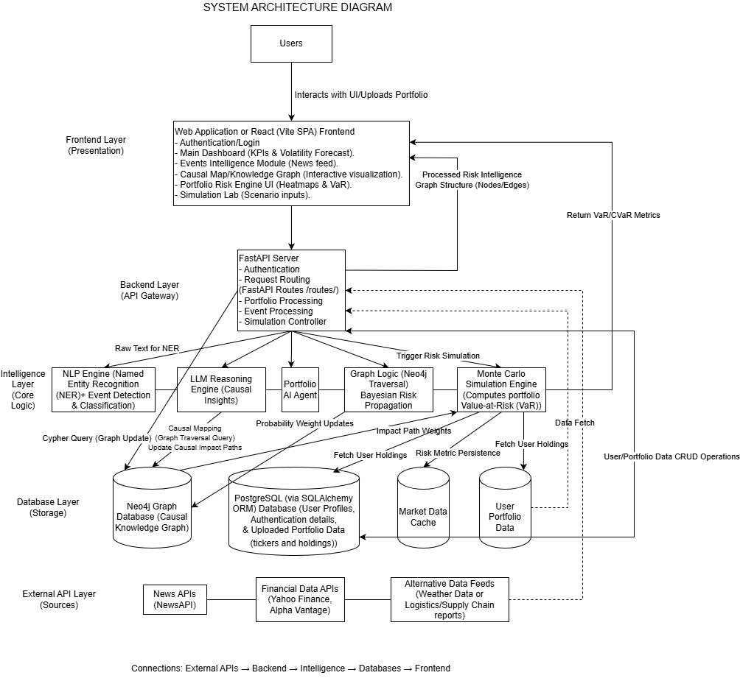
Figure 4.1 System Architecture Diagram

The System Architecture Diagram provides a high-level blueprint of the platform's four-layer stack.

- Frontend Layer: A React (Vite) web application manages the Main Dashboard, Knowledge Graph visualizations, and Simulation Lab inputs.
- Backend Layer: A FastAPI server serves as the API Gateway, handling authentication, request routing, and event coordination.
- Intelligence Layer: This core logic hub utilizes an NLP Engine for event detection, an LLM Reasoning Engine for causal insights, and a Portfolio Advisor Agent to interpret user risk queries.
- Database Layer: Employs Neo4j for graph-based causal storage and PostgreSQL for relational user profiles and portfolio data.External API Layer: Ingests data from News APIs, Financial APIs, and Broadband/Geospatial infrastructure feeds to enrich risk assessments.

B. Context Diagram

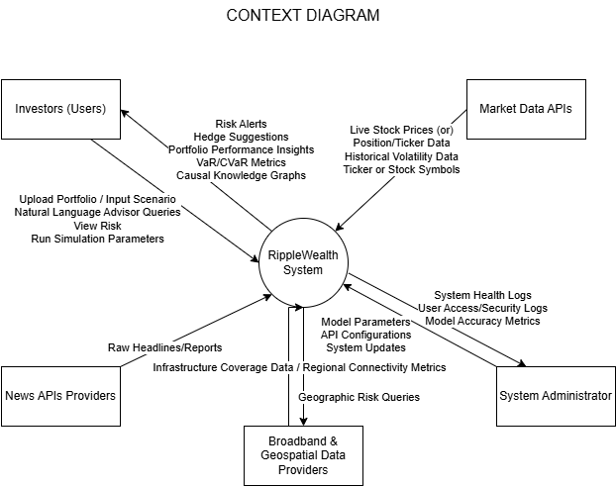
Figure 4.2 Context Diagram

The Context Diagram defines the boundaries of the RippleWealth system and its interactions with external entities.

- Investors (Users): Provide portfolio uploads and Natural Language Queries (e.g., "market crash") while receiving risk alerts and hedge suggestions.
- Market Data APIs: Supply live stock prices and historical volatility data.
- Broadband & Geospatial Providers: Supply critical infrastructure stability metrics used to assess regional "Butterfly Event" severity.
- News APIs Providers: Deliver raw headlines and reports for NLP classification.
- System Administrator: Monitors system health logs and model accuracy metrics.

C. Sequence Diagram

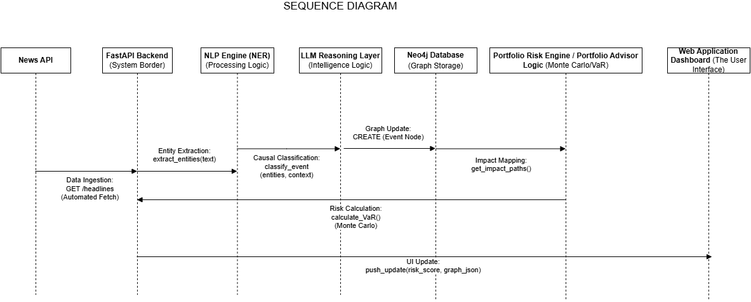
Figure 4.3 Sequence Diagram

The Sequence Diagram illustrates the time-sequenced interaction between components during an event-driven risk update.

- Data Ingestion: The process begins when the News API triggers a GET /headlines fetch.
- Processing: The NLP Engine extracts entities while the LLM Reasoning Layer classifies the event's causal impact.
- Risk Evaluation: The backend fetches Broadband Infrastructure data and executes the portfolio_agent() function to calculate impact based on user holdings.
- UI Update: Finally, the system pushes a risk_score and graph_json update to the dashboard.

D. State Diagram

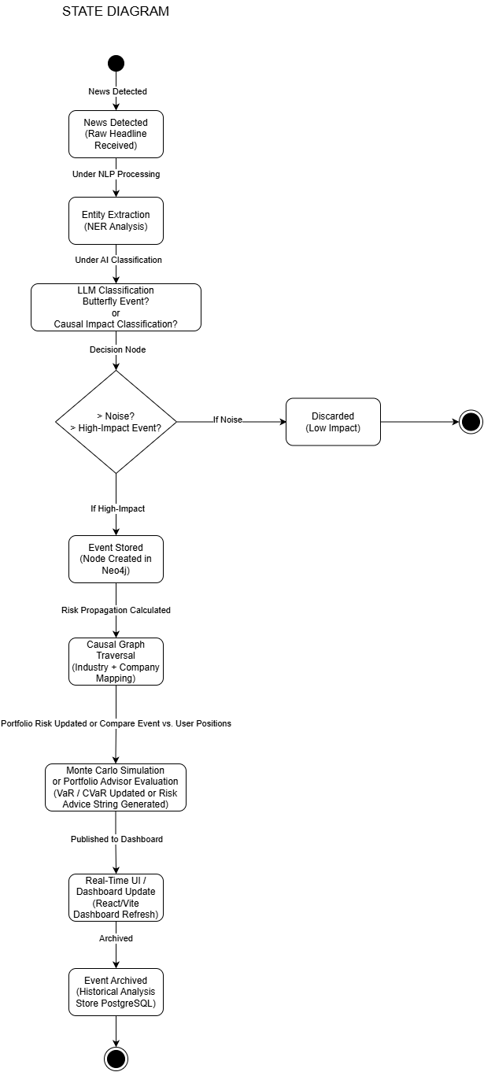
Figure 4.4 State Diagram

The State Diagram (modeled as an activity flow) tracks the lifecycle of a "Butterfly Event" from detection to archival.

- Detection & Extraction: A raw headline is received and undergoes NER Analysis.
- Enrichment: The event is checked against Infrastructure Data in SQL to determine if it meets the "High-Impact" threshold.
- Propagation: High-impact events are stored as nodes in Neo4j, followed by a causal graph traversal to map industry-to-company impacts.
- Output: The state culminates in a Portfolio Advisor Evaluation that generates natural-language advice before the event is archived.

- API DOCUMENTATION
The RippleWealth system exposes a set of RESTful endpoints implemented using the FastAPI library and can be accessed using HTTP GET and POST requests. These endpoints enable interaction between the frontend interface and backend modules responsible for portfolio analysis, event tracking, risk computation, simulation, and recommendation generation.

- The /events endpoint returns a list of global events with attributes including title, affected industry, severity level, and confidence score.
- The /portfolio endpoint returns a list of assets, including their associated tickers and investment values.
- The /portfolio/risk endpoint provides computed metrics such as Value at Risk (VaR), Conditional Value at Risk (CVaR), and sector exposure distribution.
- The /recommend endpoint accepts an event as input and generates investment recommendations.
- The /simulate endpoint accepts a JSON object containing a selected event and computes a projected portfolio value over a series of time steps.
- The /rebalance endpoint provides a recommended portfolio reallocation strategy by comparing the current portfolio with an optimized allocation and explaining the rationale behind the adjustments.
- The /graph endpoint returns a structured representation of relationships between events, industries, assets, and the portfolio in the form of nodes and edges.

- CONCLUSION
In conclusion, RippleWealth delivers a comprehensive solution for event-driven portfolio risk analysis and investment decision support. By integrating risk assessment, simulation, and recommendation capabilities, the platform enables users to understand and respond to market disruptions effectively.
The system demonstrates the practical application of modern web technologies and analytical methods in financial decision-making. Its architecture supports continuous enhancement, including integration with real-time data, predictive modeling, and intelligent advisory systems.
Overall, RippleWealth enhances portfolio management by providing actionable insights and enabling proactive risk mitigation in dynamic market environments.

VII. SUMMARY
RippleWealth is an event-driven portfolio intelligence platform that analyzes how global disruptions impact financial markets and investment portfolios. The system integrates a FastAPI backend with a React frontend to deliver a responsive and interactive user experience.
The platform follows a structured workflow consisting of event detection, industry impact mapping, portfolio exposure evaluation, simulation, and recommendation generation. It enables users to visualize portfolio holdings, assess risk using VaR and CVaR metrics, simulate potential outcomes, and receive data-driven investment suggestions.
A knowledge graph component models causal relationships among events, industries, and assets, thereby improving transparency and interpretability. The system is designed with a modular architecture, enabling scalability and integration with advanced analytics and real-time data sources.

